Finite Element Analysis of the Influence of Microplate Spacing on the Stability of Mandibular Ramus Fracture Fixation

Ruize Tang1,Qing Cui1,2,Shuo Ren1,UNURJARGL KHADBAATAR1,Jingxu Li1(corresponding author)

corresponding author Email Address:0000007562@ybu.edu.cn

1.Department of Stomatology, Affiliated Hospital of Yanbian University(Yanbian Hospital),Yanji 133000,Jilin， China

2. School of Stomatology, Baicheng Medical College,Baicheng,Jilin Province,137000 China

**Abstract:**

**Objective**: To investigate the effect of different microplate spacing on the relative displacement of the fractured mandibular ramus during mastication after using double microplates for fixation, using finite element analysis. This study aims to provide a theoretical basis for clinical design of the distance between two microplates.

**Methods**: Finite element models of the mandible, teeth, periodontal membrane, and microplates (Johnson & Johnson, thickness 1mm) were established. A fracture line was set on the mandibular ramus from the sigmoid notch to the angle of the mandible, corresponding to the type I fracture line of the mandibular ramus. The experiment designed the distance between two microplates into 22 groups, with 2mm as the initial distance and an increase of 1mm per step, gradually increasing the distance between the two microplates to 23mm. Friction contact was set between the two fracture fragments, and the bilateral condyles were fixed. A bite force of 230N was applied to the bilateral first molars, and the relative displacement between the two fracture fragments under this load was calculated.

**Results**: The results showed that as the distance between the microplates increased, the relative displacement gradually decreased, from 0.46751mm at a distance of 2mm to 0.105789mm at a distance of 23mm. The relative displacement at a distance of 20mm was 0.147448mm, which was below the clinical critical value of 0.15mm for the direct healing.

**Conclusion**: After using double microplates for fixation of mandibular ramus fractures, the stability of the fracture fixation during mastication increases with the increase in the distance between the two microplates. At a distance of 20mm, While theoretically capable of achieving the criteria for direct healing, further clinical validation remains necessary.

**Keywords**: Mandibular Fracture; Rigid Internal Fixation; Microplate; Fixation Method; Finite Element Analysis

**Introduction**:

The mechanism of mandibular fracture is closely related to its anatomical characteristics. Due to its unique anatomical position as the only movable bone in the maxillofacial region and its prominent shape, the mandible has many weak areas and is prone to fractures. The incidence of mandibular fractures accounts for a large proportion of maxillofacial fractures, approximately 70% [1]. The mandibular ramus is located below the condyle and coronoid process, above the angle of the mandible, and the thickness of its bone plate is relatively thinner than that of the mandibular body. However, due to its special anatomical position, it is less prone to fractures, **The incidence of mandibular ramus fractures accounts for 17.5% of all mandibular fractures.**（1）.with an incidence only slightly higher than that of condylar and alveolar process fractures [2-4]. The main goal of fracture treatment is anatomical reduction and restoration of normal occlusion. In the past, non-invasive conservative treatment methods such as maxillomandibular fixation (MMF) were commonly used, and invasive treatment methods were less frequently used. However, current research and guidelines recommend the use of open reduction internal fixation (ORIF) [5].

Finite element analysis (FEA) is an important method for mechanical research. It can predict the mechanical response of an object by simulating different loading conditions on the object after assigning different materials to it using a computer. In 1960, Friedenberg [7] first introduced FEA into the field of medicine. In 1973, FEA was first applied to biomechanical research in dentistry by Thresher et al. [8]. This method has been widely developed in various fields of dentistry. It can model digitalized imaging data and simulate different stress conditions, with the advantages of non-destructiveness, reproducibility of experiments, and quantifiable analysis of results.

In the field of oral and maxillofacial surgery, FEA is often used in biomechanical research on topics such as the mechanical mechanism of fracture occurrence [9] and the stability analysis of fractures after fixation [10]. At present, there have been many biomechanical studies on the stability of fractures after fixation in the field of oral and maxillofacial surgery, but there is still controversy regarding the selection of spacing between two microplates for fixation of the mandibular ramus. This study will use FEA to clarify the effect of different microplate spacing on postoperative stability from a biomechanical perspective and explore the critical value of microplate spacing for direct healing after surgery, providing a theoretical basis for clinical surgical design.

**Materials and Methods**:

* 1. **Three-dimensional Reconstruction of the Mandible Model**:

A healthy adult volunteer was selected, and **Cone Beam Computed Tomography(CBCT)** was used to scan the volunteer’s maxillofacial region. This study has been approved by the Ethics Committee of Yanbian University Affiliated Hospital (2024210), and informed consent was obtained from the volunteer before the experiment. The scan results were stored in Digital Imaging and Communications in Medicine(DICOM)format. The CBCT image data were imported into the medical three-dimensional reconstruction software Mimics 26.0 (Materialise, USA). The CBCT images were three-dimensionally reconstructed through the mask command, separately reconstructing the mandible and the mandibular dentition, and saved in .stl format. In 3-Matic 18.0 (Materialise, USA), the reconstructed model was optimized by redrawing the grid, local smoothing, and checking for problems such as overlapping surfaces and missing surfaces. The “Uniform Offset” command was used to establish a cancellous bone model of the maxilla and to establish a uniformly enlarged dentition required for the periodontal membrane.

* 1. **Establishment of the Finite Element Model**:

The above-mentioned .stl three-dimensional model was imported into the SpaceClaim sub-module of the finite element analysis software Ansys 2021R (ANSYS, USA). The AutoSkin function can convert the shell of the three-dimensional model into a solid body. The periodontal membrane was set as a 0.25mm thick homogeneous periodontal membrane. The finite element models of cortical bone, cancellous bone, alveolar socket, and periodontal membrane were realized through the combination function. A type I fracture line of the mandibular ramus (Figure 1) was set, and microplates were used for fixation at both ends of the fracture line. In this study, a four-hole microplate from Johnson & Johnson was used. The initial distance between the two microplates was set to 2mm, with a step length of 1mm, and the distance between the two microplates was gradually increased to 23mm (Figure 2).

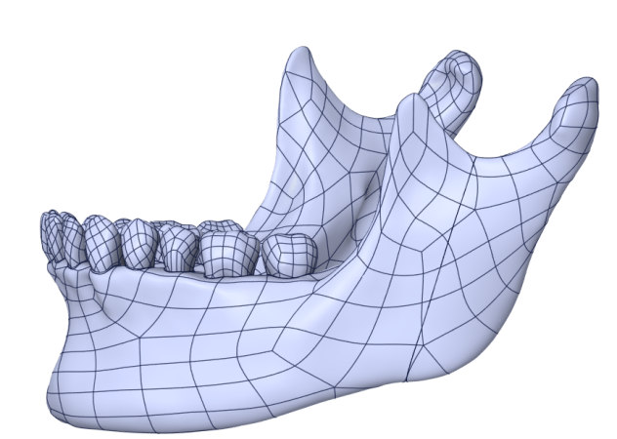

**Figure 1. Type I Fracture Line of the Mandibular Ramus**

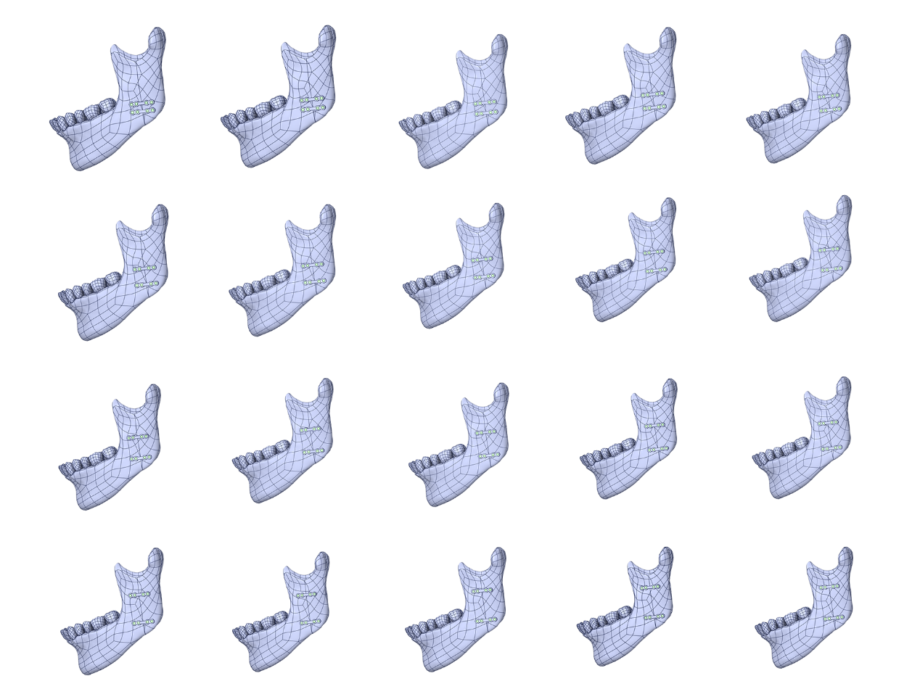

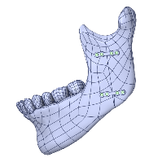

**Figure 2. Design of Microplate Spacing (2mm-23mm**)

* 1. **Finite Element Analysis**:

The material properties, mesh size, boundary conditions, and reference coordinate system of each part of the model were set, and the reference coordinate system was established. Finally, the load was applied and the displacement was solved. The material properties were assigned based on the parameters used in previous studies [11, 12] (Table 1), and they were considered as linear elastic isotropic homogeneous materials. The condyles of the mandible were fixed, and the contact between the teeth, periodontal membrane, and mandible was set as fixed contact. Friction contact was set between the two fracture fragments, with a friction coefficient of 0.3. Two coordinate systems perpendicular to the mandible and perpendicular to the fracture line were set as the coordinate systems for applying the load and solving the relative displacement. A bite force of 230N was applied to the bilateral first molars (Figure 3), and the relative displacement between the two fracture fragments was evaluated.

**Table 1. Material Properties**

|  |  |  |
| --- | --- | --- |
| Material | Elastic Modulus / MPa | Poisson’s Ratio |
| Tooth  Periodontal membrane | 18600  68 | 0.31  0.45 |
| Cortical bone | 13700 | 0.3 |
| Trabecular bone | 1370 | 0.3 |
| Microplate | 110300 | 0.31 |

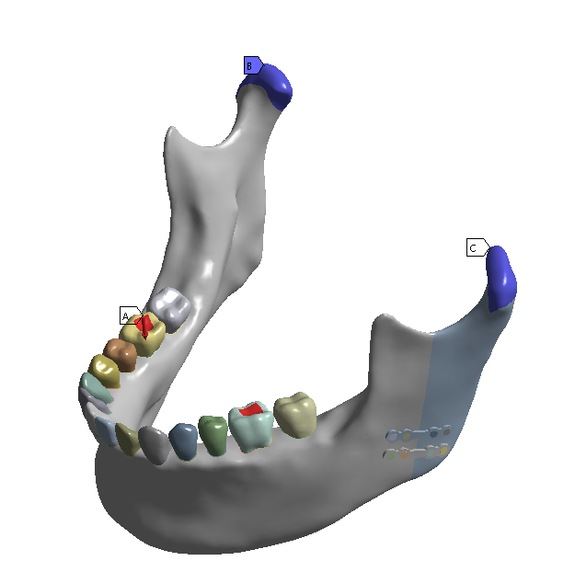

**Figure 3. Setting of Boundary Conditions**

**Results**:

As the distance between the two microplates gradually increased, the relative displacement gradually decreased. At a distance of 20mm, the relative displacement was 0.105789mm, which could achieve the effect of the direct healing (Table 2).

**Table 2. Relative Displacement at Different Microplate Spacings**

|  |  |  |
| --- | --- | --- |
| Microplate Spacing（mm） | Relative Displacement（mm） | Evaluation Criteria  （mm） |
| 2 | 0.46751 | >0.15 |
| 3 | 0.4395 | >0.15 |
| 4 | 0.430741 | >0.15 |
| 5 | 0.39318 | >0.15 |
| 6 | 0.388731 | >0.15 |
| 7 | 0.359678 | >0.15 |
| 8 | 0.347085 | >0.15 |
| 9 | 0.333203 | >0.15 |
| 10 | 0.319047 | >0.15 |
| 11 | 0.303988 | >0.15 |
| 12 | 0.28828 | >0.15 |
| 13 | 0.271427 | >0.15 |
| 14 | 0.255314 | >0.15 |
| 15 | 0.231904 | >0.15 |
| 16 | 0.212232 | >0.15 |
| 17 | 0.195081 | >0.15 |
| 18 | 0.177794 | >0.15 |
| 19 | 0.163164 | >0.15 |
| 20 | 0.147448 | <0.15 |
| 21 | 0.13127 | <0.15 |
| 22 | 0.117397 | <0.15 |
| 23 | 0.105789 | <0.15 |

**Discussion**:

Agarwal [14] classified mandibular ramus fractures into five types. Types I and II are vertical fractures, with type I extending from the sigmoid notch to the angle of the mandible and type II extending from the coronoid process to the angle of the mandible. Type III is a horizontal fracture extending from the anterior edge to the posterior edge of the mandibular ramus. Type IV is an oblique fracture extending from the posterior edge of the mandibular ramus to the lower edge of the mandible. Type V is a comminuted fracture. Among these, type I fracture is the most common, accounting for approximately 48.5% of all fracture types [15, 16]. Therefore, this study focused on the most common type I fracture line.

**ORIF** is a commonly used treatment method for maxillofacial fractures. It offers advantages such as functional and anatomical reduction of fractures, early functional recovery, and ease of maintaining oral hygiene [14]. Therefore, ORIF is widely chosen in clinical practice.

**Champy and Lodde[17] and Champy[18]** first proposed the concept of a tension band in the mandibular angle, where the upper part of the fracture line experiences greater displacement due to the bite force during mastication, acting as a tension band, while the lower part experiences compression and has less displacement, acting as a pressure band. His research elucidated the ideal fixation route for mandibular angle fractures, suggesting that fixation of the tension band alone can achieve satisfactory results. Unlike mandibular angle fractures, type I mandibular ramus fractures have a longer fracture line extending vertically through the entire mandibular ramus. Literature indicates that type I mandibular ramus fractures require a two-point fixation method to achieve stable fixation [14]. Therefore, this study employed double microplates for fracture fixation.

The bite force generated at different tooth positions during mastication varies. For example, the bite force in the anterior tooth region ranges from 100 to 370N, while the bite force in the posterior tooth region ranges from 50 to 400N [19]. The bite forces mentioned in the above studies are the maximum bite forces. However, due to postoperative pain, swelling, and limited mouth opening, patients are often advised to consume liquid foods, which prevents the exertion of maximum bite forces under normal conditions. Therefore, this study selected a light bite force, equivalent to the force exerted when chewing gum, approximately 230N [13].

The results of this study demonstrated that as the distance between the two microplates increased, the relative displacement between the two bone fragments gradually decreased, resulting in improved postoperative stability. During mastication, the anterior bone fragment exhibited forward and downward rotation, with the maximum displacement occurring at the sigmoid notch, i.e., the tension band. This finding aligns with Champy’s research [17, 18]. When the upper microplate is located closer to the sigmoid notch, it significantly reduces displacement at this location, effectively stabilizing the bone fragment.

In the treatment of mandibular ramus fractures, various surgical approaches can be selected, such as the submandibular approach (Risdon approach), the posterior approach through the masseter muscle, and the posterior approach through the parotid gland [14]. Hinds [20] first described the posterior approach through the parotid gland in 1967, and subsequent reports have described various modified approaches, including the transmasseteric and transparotid approaches. The posterior approach requires dissection of the parotid sheath, dissection of the parotid gland, and separation and protection of the facial nerve. Due to the need for traction and separation of these important anatomical structures during surgery, the incidence of postoperative complications is relatively high. Studies have reported a high incidence of facial nerve injury following the posterior approach, with rates as high as 38%-40% and 1% of cases experiencing permanent facial nerve damage [21]. Risdon [22] first described the Risdon approach, which was later modified by Meyer [23]. This approach features a more concealed incision and a lower risk of nerve injury. Prabhu [24] found that the incidence of nerve injury was only 16.6% in cases treated using the Risdon approach. Similarly, Mehra [25] chose the Risdon approach for the treatment of mandibular fractures, with a 23% incidence of nerve injury. Therefore, the Risdon approach has a lower incidence of postoperative complications. Mehra [26] compared the exposure range of the posterior approach and the Risdon approach and found a significant difference. The Risdon approach provides inadequate exposure to the sigmoid notch and the base of the condyle, making it difficult to achieve sufficient exposure.

In clinical practice, surgeons aim to minimize incisions for aesthetic purposes and to reduce the risk of postoperative complications. However, an excessively large distance between the two microplates may necessitate a change in the surgical approach. Within the scope of achieving optimal postoperative healing standards, reducing the distance between the microplates may allow for a change in the surgical approach, such as using the Risdon approach, to minimize incisions and reduce the risk of complications.

Fracture healing directly affects the long-term therapeutic outcomes. Clinically, fracture healing is typically classified into two types: direct healing and indirect healing. Direct healing occurs when the fracture ends are in close contact and fixed stably. The healing process involves direct remodeling of lamellar bone and Haversian systems without the formation of callus. Direct healing is rapid, usually completing within a few weeks to several months. Indirect healing, or gap healing, occurs when there is a gap between the fracture ends. The healing process involves the formation of cartilaginous callus and periosteal callus, followed by angiogenesis, mineralization, absorption, and remodeling, ultimately forming lamellar bone. Indirect healing is slow, typically requiring several months to a few years to complete [27]. Studies have shown that when the relative displacement between the fracture ends is within 0.15mm, direct healing can be achieved . **In this experiment, the fracture gap was set to 1mm, and the relative displacement of the fracture during functional activities was measured[28]**. This study employed a tightly contacting fracture gap setting because, in clinical practice, when using ORIF, the exposure range of the bone surface is large, allowing surgeons to directly visualize and control the fracture gap under direct vision. The relative displacement refers to the movement between the two fracture fragments under bite force. This study used the origin of the sigmoid notch as the coordinate system (Figure 4). After applying bite force, the origin undergoes displacement. By calculating the distance between the two points in space (Figure 5), the relative displacement between the two fracture fragments can be measured.

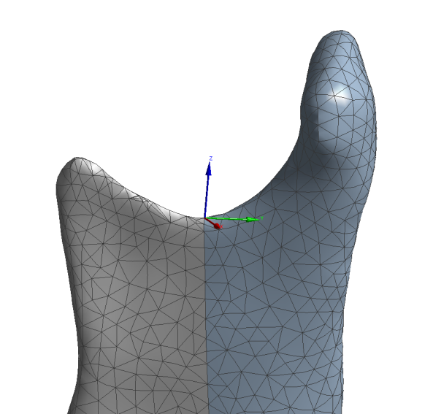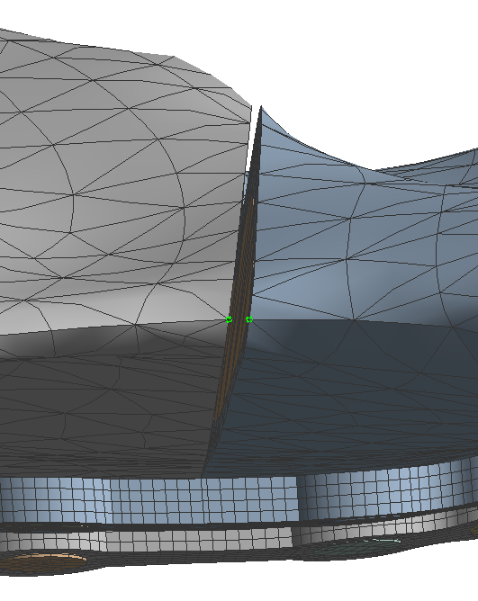

**Figure 4. Origin Setting Figure 5. Relative Displacement Distance**

The experimental results showed that when the distance between the two microplates was 20mm, the relative displacement between the two fracture ends was 0.105789mm, achieving the goal of direct healing. Clinically, this distance can be used to minimize surgical incisions, such as using the Risdon approach, to reduce the risk of complications.

This study has certain limitations. In reality, the maxillofacial region also contains soft tissues such as muscles, ligaments, parotid glands, and skin, which exert a certain restrictive effect on the displacement of the fractured fragments after surgery. Finite element analysis in biomechanical research is difficult to fully simulate real-world conditions. This study employed the concept of maximizing values, setting a larger bite force and not simulating soft tissues. The theoretical value obtained in this finite element analysis, where the distance between the two microplates is 20mm and the relative displacement is 0.105789mm, would be smaller in real-world clinical conditions.

**Conclusion**:

This study utilized finite element analysis to investigate the impact of microplate spacing on the stability of mandibular ramus fractures after double microplate fixation. The results demonstrated that increasing the distance between the microplates enhances postoperative stability. At a distance of 20mm, the relative displacement reaches 0.105789mm, Theoretically, it can meet the requirements of direct healing of fractures. However, due to the inability of simulation analysis to fully replicate the actual state of patients, further clinical research is warranted to validate this conclusion. We will verify this conclusion through clinical research in future studies.

**References:**

1. Pickrell, B. B.; Serebrakian, A. T.; Maricevich, R. S., Mandible Fractures. *Semin Plast Surg* **2017,** 31, (2), 100-107.

2. Boole, J. R.; Holtel, M.; Amoroso, P.; Yore, M., 5196 mandible fractures among 4381 active duty army soldiers, 1980 to 1998. *Laryngoscope* **2001,** 111, (10), 1691-6.

3. Olson, R. A.; Fonseca, R. J.; Zeitler, D. L.; Osbon, D. B., Fractures of the mandible: a review of 580 cases. *J Oral Maxillofac Surg* **1982,** 40, (1), 23-8.

4. Subhashraj, K.; Nandakumar, N.; Ravindran, C., Review of maxillofacial injuries in Chennai, India: a study of 2748 cases. *Br J Oral Maxillofac Surg* **2007,** 45, (8), 637-9.

5. Barde, D. H.; Mudhol, A.; Ali, F. M.; Madan, R. S.; Kar, S.; Ustaad, F., Efficacy of 3-Dimensional plates over Champys miniplates in mandibular anterior fractures. *J Int Oral Health* **2014,** 6, (1), 20-6.

6. Welch-Phillips, A.; Gibbons, D.; Ahern, D. P.; Butler, J. S., What Is Finite Element Analysis? *Clin Spine Surg* **2020,** 33, (8), 323-324.

7. Friedenberg, R., "Direct analysis" or "finite element analysis" in biology: a new computer approach. *Curr Mod Biol* **1969,** 3, (2), 89-94.

8. Thresher, R. W.; Saito, G. E., The stress analysis of human teeth. *J Biomech* **1973,** 6, (5), 443-9.

9. Sancar, B.; Çetiner, Y.; Dayı, E., Evaluation of the pattern of fracture formation from trauma to the human mandible with finite element analysis. Part 2: The corpus and the angle regions. *Dent Traumatol* **2023,** 39, (5), 437-447.

10. Li, Y.; Li, H.; Lai, Q.; Xue, R.; Zhu, K.; Deng, Y., Finite element analysis of 3D-printed personalized titanium plates for mandibular angle fracture. *Comput Methods Biomech Biomed Engin* **2023,** 26, (1), 78-89.

11. Coyac, B. R.; Salvi, G.; Leahy, B.; Li, Z.; Salmon, B.; Hoffmann, W.; Helms, J. A., A novel system exploits bone debris for implant osseointegration. *J Periodontol* **2021,** 92, (5), 716-726.

12. Solberg, K.; Heinemann, F.; Pellikaan, P.; Keilig, L.; Stark, H.; Bourauel, C.; Hasan, I., Finite element analysis of different loading conditions for implant-supported overdentures supported by conventional or mini implants. *Comput Methods Biomech Biomed Engin* **2017,** 20, (7), 770-782.

13. Hagberg, C., Electromyography and bite force studies of muscular function and dysfunction in masticatory muscles. *Swed Dent J Suppl* **1986,** 37, 1-64.

14. Agarwal, P.; Mehrotra, D., Mandibultar Ramus Fractures: A Proposed Classification. *Craniomaxillofac Trauma Reconstr* **2020,** 13, (1), 9-14.

15. Jadhav, A.; Mundada, B.; Deshmukh, R.; Bhutekar, U.; Kala, A.; Waghwani, K.; Mishra, A., Mandibular Ramus Fracture: An Overview of Rare Anatomical Subsite. *Plast Surg Int* **2015,** 2015, 954314.

16. Kale, T. P.; Kotrashetti, S. M.; Louis, A.; Lingaraj, J. B.; Sarvesh, B. U., Mandibular ramus fractures: a rarity. *J Contemp Dent Pract* **2013,** 14, (1), 39-42.

17. Champy, M.; Lodde, J. P., [Mandibular synthesis. Placement of the synthesis as a function of mandibular stress]. *Rev Stomatol Chir Maxillofac* **1976,** 77, (8), 971-6.

18. Champy, M.; Wilk, A.; Schnebelen, J. M., [Tretment of mandibular fractures by means of osteosynthesis without intermaxillary immobilization according to F.X. Michelet's technic]. *Zahn Mund Kieferheilkd Zentralbl* **1975,** 63, (4), 339-41.

19. Paphangkorakit, J.; Osborn, J. W., The effect of pressure on a maximum incisal bite force in man. *Arch Oral Biol* **1997,** 42, (1), 11-7.

20. Hinds, E. C.; Girotti, W. J., Vertical subcondylar osteotomy: a reappraisal. *Oral Surg Oral Med Oral Pathol* **1967,** 24, (2), 164-70.

21. Manisali, M.; Amin, M.; Aghabeigi, B.; Newman, L., Retromandibular approach to the mandibular condyle: a clinical and cadaveric study. *Int J Oral Maxillofac Surg* **2003,** 32, (3), 253-6.

22. Risdon, F., The Treatment of Fractures of the Jaws. *Can Med Assoc J* **1929,** 20, (3), 260-2.

23. Meyer, C.; Zink, S.; Wilk, A., [Modified Risdon approach for the treatment of subcondylar fractures of the mandible]. *Rev Stomatol Chir Maxillofac* **2006,** 107, (6), 449-54.

24. Prabhu, R. K.; Sinha, R.; Chowdhury, S. K.; Chattopadhyay, P. K., Evaluation of facial nerve function following surgical approaches for maxillofacial trauma. *Ann Maxillofac Surg* **2012,** 2, (1), 36-40.

25. Mehra, P.; Murad, H., Internal fixation of mandibular angle fractures: a comparison of 2 techniques. *J Oral Maxillofac Surg* **2008,** 66, (11), 2254-60.

26. Ruiz, R.; Schlund, M.; Raoul, G.; Kyheng, M.; Fontaine, C.; Nicot, R., Mandibular subcondylar fracture accessibility with transparotid approach by rhytidectomy and modified Risdon approach: An anatomical comparative study. *J Craniomaxillofac Surg* **2018,** 46, (12), 2256-2260.

27. Marsell, R.; Einhorn, T. A., The biology of fracture healing. *Injury* **2011,** 42, (6), 551-5.

28. Claes, L.; Augat, P.; Suger, G.; Wilke, H. J., Influence of size and stability of the osteotomy gap on the success of fracture healing. *J Orthop Res* **1997,** 15, (4), 577-84.

**Declarations:**

Ethics approval and consent to participate:

This study has been approved by the Ethics Committee of the Affiliated Hospital of Yanbian University(YYLL2024210), and the consent of the volunteers has been obtained with the signed informed consent forms.

Consent for publication:

Not applicable.

Availability of data and materials:

All data generated or analysed during this study are included in this published article.

Competing interests:

The authors declare that they have no competing interests.

Funding:

Not applicable.

Authors' contributions:

Tang Ruize: Thesis design, model establishment, simulation experiments, and thesis writing

Cui Qing: Data analysis, literature collection

Ren Shuo: Literature collection

UNURJARGL KHADBAATAR: Literature collection

Li Jingxu: Guidance on thesis design, supervision of experiments, and article revision

1. Patterns Associated with Adult Mandibular Fractures in Southern Taiwan-A Cross-Sectional Retrospective Study